**Name: E. Sai Manoj Mis. No.: 112015044**

**Code:**

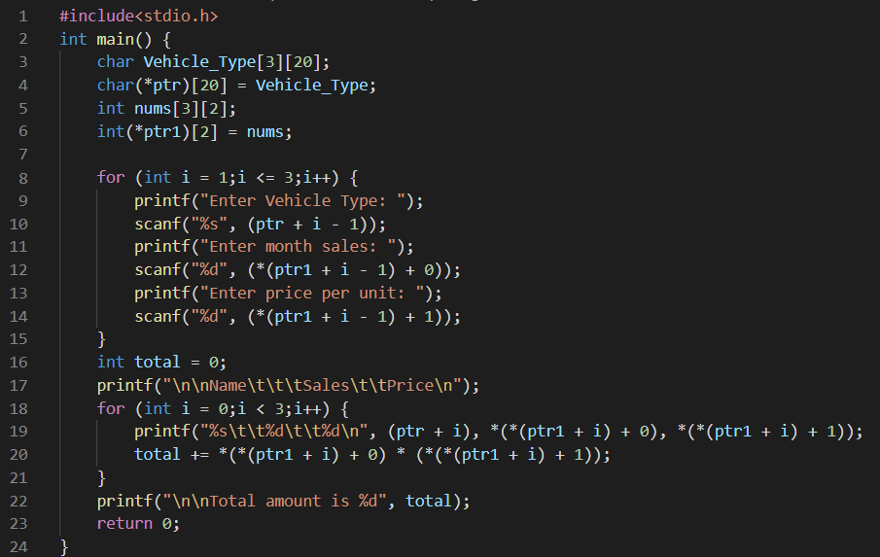

**Output:**

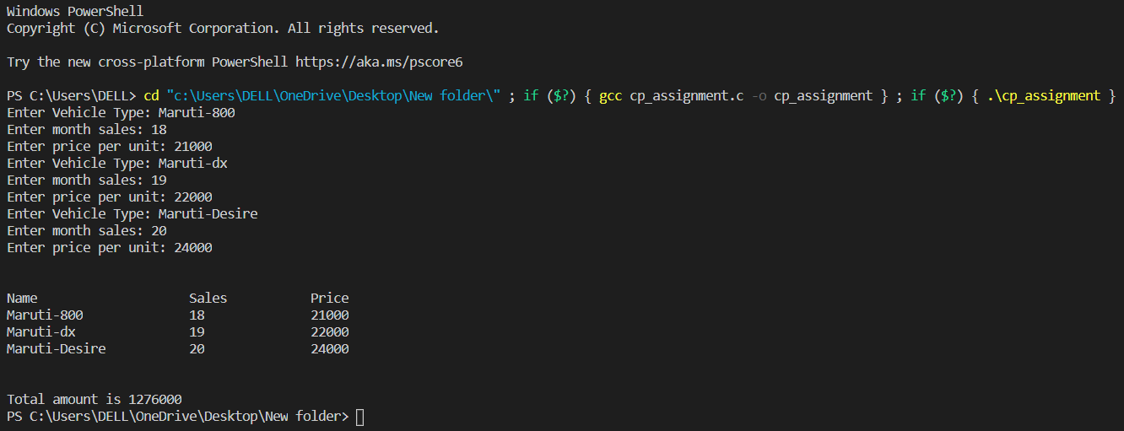

**Code:**

#include<stdio.h>

int main() {

char Vehicle_Type[3][20];

char(*ptr)[20] = Vehicle_Type;

int nums[3][2];

int(*ptr1)[2] = nums;

for (int i = 1;i <= 3;i++) {

printf("Enter Vehicle Type: ");

scanf("%s", (ptr + i - 1));

printf("Enter month sales: ");

scanf("%d", (*(ptr1 + i - 1) + 0));

printf("Enter price per unit: ");

scanf("%d", (*(ptr1 + i - 1) + 1));

}

int total = 0;

printf("\n\nName\t\t\tSales\t\tPrice\n");

for (int i = 0;i < 3;i++) {

printf("%s\t\t%d\t\t%d\n", (ptr + i), *(*(ptr1 + i) + 0), *(*(ptr1 + i) + 1));

total += *(*(ptr1 + i) + 0) * (*(*(ptr1 + i) + 1));

}

printf("\n\nTotal amount is %d", total);

return 0;

}